

REACT JS PROJECT REPORT ON
MOVIE TICKET BOOKING SYSTEM

Submitted by
SOUNDARIYAN E
24BIT052

Under the Guidance of
ARAVIND
Technical Trainer
Technical Department, KG College of Arts and Science

Academic Year: 2025 – 2026
APRIL 2026

DECLARATION
I hereby declare that the project entitled “MOVIE TICKET BOOKING SYSTEM” submitted in partial fulfillment of the requirements for the course REACT JS DEVELOPMENT is a record of my original work carried out under the guidance of ARAVIND, Technical Trainer, Technical Department, KG College of Arts and Science.
I further declare that this project has not been submitted previously, either in part or in full, for the award of any degree, diploma, or other similar title, at this or any other institution.
I have acknowledged all sources of information used in this project wherever applicable.

April 2026
Coimbatore

________________________
SOUNDARIYAN E

CERTIFICATE
This is to certify that the project entitled “MOVIE TICKET BOOKING SYSTEM” is a bona fide work carried out by SOUNDARIYAN E , II BSc IT-A, BSc INFORMATION TECHNOLOGY, KG College of Arts & Science, in partial fulfillment of the requirements for the course REACT JS DEVELOPMENT.
This project has been completed under my supervision and guidance during the academic period April 2026.

Place:
Date:

Submitted for the Viva-Voce Examination held on __________________________________

Guide: Head of the Department
(Technical Trainer, KGCAS) (Technical Head, KGCAS)

______________________ _______________________

TABLE OF CONTENTS
S. No. | Topics | Page. No.
1 | Introduction
1.1 | Background of the Study
1.2 | Problem Statement
1.3 | Objectives of the Project
1.4 | Purpose and Significance
1.5 | Scope and Limitations
1.6 | Methodology Overview
2 | System Analysis
2.1 | Existing System
2.2 | Drawbacks of the Existing System
2.3 | Proposed System
2.4 | Features of the Proposed System
2.5 | Feasibility Study
2.6 | Requirement Analysis
3 | System Design
3.1 | System Architecture
3.2 | Use Case Diagram
3.3 | Data Flow Diagram (DFD)
3.4 | Entity Relationship Diagram (ERD)
3.5 | User Interface Design
4 | System Implementation
4.1 | Development Tools
4.2 | Module Description
4.3 | Algorithms
4.4 | System Integration
4.5 | Security and Validation
5 | System Testing
5.1 | Testing Methodology
5.2 | Test Cases
5.3 | Error Handling
5.4 | Performance
6 | Input and Output Screens
6.1 | System Outputs
6.2 | Discussion
6.3 | Comparison
6.4 | User Feedback
7 | Conclusion and Future Enhancement
7.1 | Summary
7.2 | Limitations
7.3 | Future Scope
8 | References
Appendices
- Source Code Snippets
- Screenshots of Web Pages

ABSTRACT

The Movie Ticket Booking System is a web-based application developed using React.js to simplify the process of booking movie tickets online. The system allows users to select movies, view movie posters, choose available seats, and book tickets with real-time updates.
The application provides an interactive and user-friendly interface where users can easily select seats and view booking status such as available, selected, and booked seats. The system dynamically calculates ticket prices based on the number of seats selected.
React state management is used to handle seat selection, booking status, and UI updates efficiently. The system also includes validation to ensure proper booking, such as preventing booking without selecting seats.
This project demonstrates how modern web technologies can be used to build responsive and dynamic applications for real-world use cases like online ticket booking systems.

Chapter 1: Introduction
  - Background of the Study

With the advancement of digital technology, online booking systems have become essential in the entertainment industry. Traditional ticket booking methods are time-consuming and inconvenient. A web-based movie ticket booking system simplifies the process by allowing users to book tickets anytime and anywhere.

  - Problem Statement

Manual booking systems and existing platforms may involve long queues, limited accessibility, and lack of real-time seat availability. There is a need for a simple, efficient, and interactive system that allows users to book tickets easily.

1.3 Objectives of the Project
- To develop a movie ticket booking system using React
- To provide seat selection functionality
- To display real-time booking status
- To calculate total ticket cost dynamically.

1.4 Purpose and Significance of the Study
- Improves user convenience
- Saves time
- Provides real-time seat availability
- Demonstrates React-based UI development
1.5 Scope and Limitations
- Scope:
• Movie selection
- Seat booking
- Price calculation
- Limitations:
• No payment integration
- No database storage
- No user login system

1.6 Methodology Overview
The project follows a structured Software Development Life Cycle (SDLC) approach consisting of Requirement Analysis, Design, Development, Testing, and Implementation. The tools used include Visual Studio Code, HTML5, CSS3, and JavaScript for creating an interactive user experience.

Chapter 2: System Analysis
2.1 Existing System

- Manual ticket booking
- No real-time updates
- Time-consuming process

2.2 Drawbacks of the Existing System
- Long queues
- No seat availability visibility
- Not user-friendly

2.3 Proposed System
- Online booking system using React
- Interactive UI
- Real-time seat selection

2.4 Features of the Proposed System
- Movie selection
- Movie poster display
- Seat selection (Available / Booked / Selected)
- Price calculation
- Validation messages

2.5 Feasibility Study
Technical: React-based frontend
Economic: Low cost
Operational: Easy to use

2.6 Requirement Analysis
Functional Requirements:
- Select movie
- Select seats
- Book tickets
Non-Functional Requirements:
- Fast performance
- User-friendly UI

Chapter 3: System Design
3.1 Introduction
System design is an important phase in software development where the overall structure and architecture of the system are defined. It acts as a blueprint that converts the requirements gathered during the analysis phase into a clear and organized plan for implementation.
In this project, the Movie Ticket Booking System is designed to provide a simple, interactive, and user-friendly interface for booking movie tickets. The design focuses on how users interact with the system, how seat selection is handled, and how booking operations are performed efficiently.
The system is developed using React.js, which enables dynamic user interface updates through state management. The design ensures smooth navigation between components such as movie selection, seat layout, and booking confirmation.
The main goal of the system design is to:
- Ensure a responsive and attractive user interface
- Provide real-time seat availability updates
- Maintain clear separation between UI, logic, and data
- Enable easy scalability for future enhancements
Overall, the system design ensures that the application is efficient, maintainable, and capable of delivering a seamless movie ticket booking experience.

3.2 System Architecture
The system follows a three-layer architecture — Presentation Layer (Frontend), Application Logic Layer, and Data Layer.
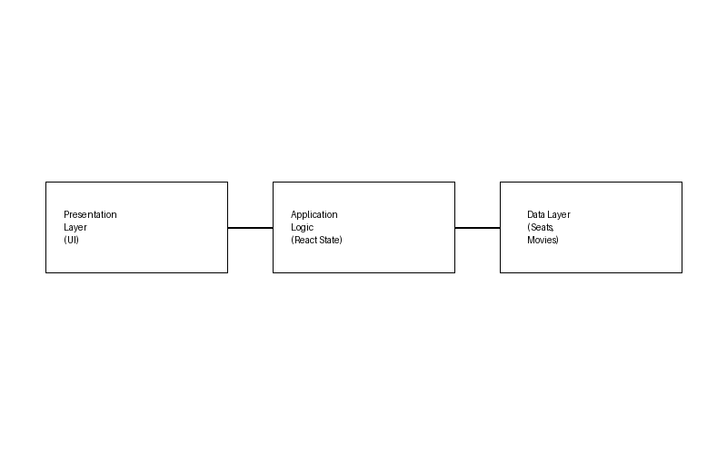

Description:
- The Presentation Layer interacts with the user
- It sends input to the Application Logic Layer
- The logic processes data and updates the Data Layer
- Updated data is reflected back in the UI

3.3 Use Case Diagram
1. What is a Use Case Diagram?
A Use Case Diagram visually shows:
- Actors → the users or external systems interacting with your application.
- Use Cases → the actions they can perform.
- Relationships → how those actions connect.
It helps you explain “Who does what” in your system.

2. Identify the Main Actors
Actor | Description
User / Customer | The main actor who selects movies, views movie details, chooses seats, and books tickets.
Administrator (Optional) | Manages movie details, seat availability, and booking data (future enhancement).
Guest/Visitor (Optional) | Can view available movies but may need to select before booking.

3. Identify the Main Use Cases
For User / Customer

Use Case | Description
Select Movie | User selects a movie from the dropdown list
View Movie Poster | Displays the selected movie image/banner
View Seat Availability | Shows available, selected, and booked seats
Select Seats | User selects seats for booking
Calculate Total Price | System calculates total based on selected seats
Book Ticket | User confirms booking of selected seats
View Confirmation | Displays success message after booking

For Administrator
Use Case | Description
Manage Movies | Add, edit, or delete movie details
Manage Seats | Update seat availability
View Bookings | Monitor user bookings

4. Define Relationships
- Association shows the interaction between the user (actor) and the system.
- <<include>> represents a mandatory action that must be performed as part of another use case.
- <<extend>> represents an optional or conditional action that occurs only under certain conditions.
For example, in the Movie Ticket Booking System, the use case “Book Ticket” includes “Select Seats”, because selecting seats is necessary before booking a ticket. Another example is “View Confirmation” extends “Book Ticket”, as the confirmation message is displayed only after the booking is successfully completed.

5. Draw the Diagram (Structure Example)
Tools you can use:
- draw.io (free online)
- Lucidchart
- StarUML
- MS Visio
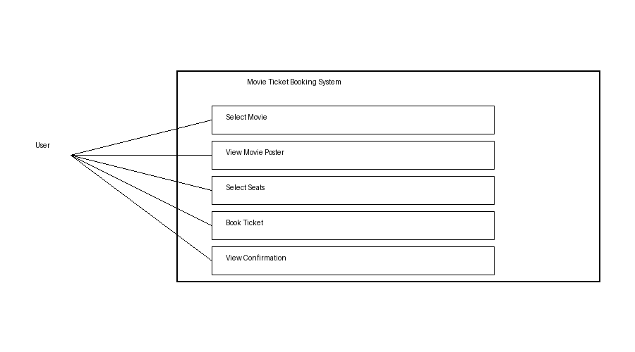

6. Example Explanation (Text Description)
Actors:
User: The main actor who interacts with the system to select movies, choose seats, and book tickets.
Use Cases:
- Select Movie: The user selects a movie from the available list.
- View Movie Poster: The system displays the selected movie image.
- Select Seats: The user chooses available seats for booking.
- Book Ticket: The user confirms the booking of selected seats.
- View Confirmation: The system displays a success message after booking.
Relationships:
- “BookTicket” includes “Select Seats”
→ The user must select seats before booking tickets.
- “View Confirmation” extends “Book Ticket”
→ Confirmation is shown only after successful boo
7. Step-by-Step (Using draw.io)
- Open app.diagrams.net
- Create Blank Diagram
- Draw a Rectangle → “Movie Ticket Booking System”
- Add Actor (User) outside the box
- Add Ovals (Use Cases):
- Select Movie
- Select Seats
- Book Ticket
- View Confirmation
- Connect User → Use Cases
- Add:
- <<include>> (Book Ticket → Select Seats)
- <<extend>> (View Confirmation → Book Ticket)
- Export as PNG/JPG

3.4 Data Flow Diagram (DFD)
1. What is a Data Flow Diagram (DFD)?
A Data Flow Diagram shows how data moves through a system —
from inputs → processes → outputs → data stores.
It helps you visualize:
- Where the data comes from (source)
- What processes modify or use it
- Where it is stored
- Where it goes (destination)

2. DFD Symbols You’ll Use
Symbol | Name | Description
Rectangle | External Entity | Represents the user or external system (e.g., User)
Circle / Rounded Rectangle | Process | Represents an action or operation (e.g., Book Ticket, Select Seats)
Two Parallel Lines | Data Store | Stores data (e.g., Movie Data, Seat Data)
Arrow | Data Flow | Shows the flow of data between components

3. Levels of DFD
- Level 0: Shows whole system as one process
- Level 1: Shows main processes (movie, seats, booking)
- Level 2: Shows detailed sub-processes
4. Steps to Create a DFD
- Identify External Entities (User)
- Identify Processes (Select Movie, Book Ticket)
- Identify Data Stores (Movie Data, Seat Data)
- Identify Data Flow (input/output arrows)
- Draw and connect all components
- DFD for Educational Website
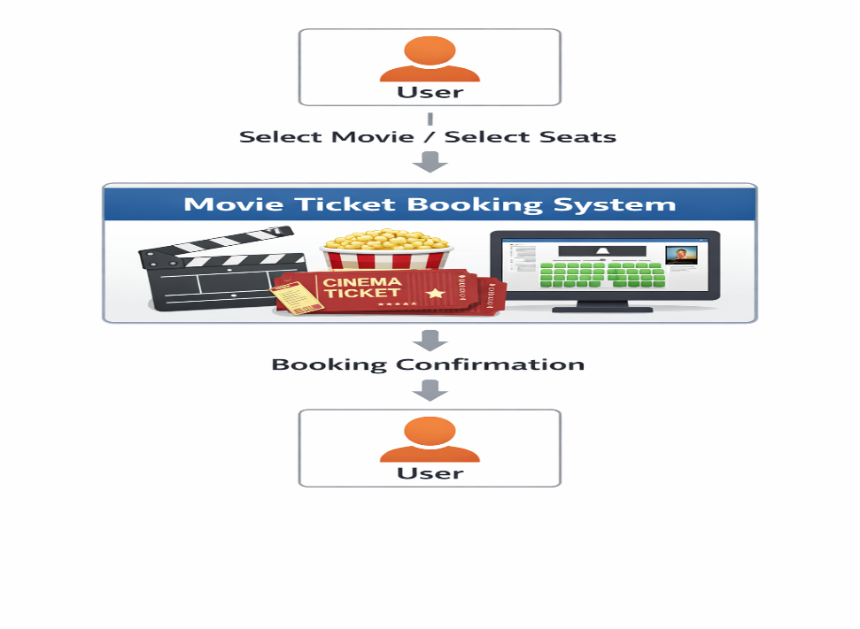
Level 0: Context Diagram
Explanation:
Level 0 DFD shows the entire system as a single process.
The User interacts with the Movie Ticket Booking System by giving input (select movie, seats) and receiving output (booking confirmation).
Level 1: Detailed System View
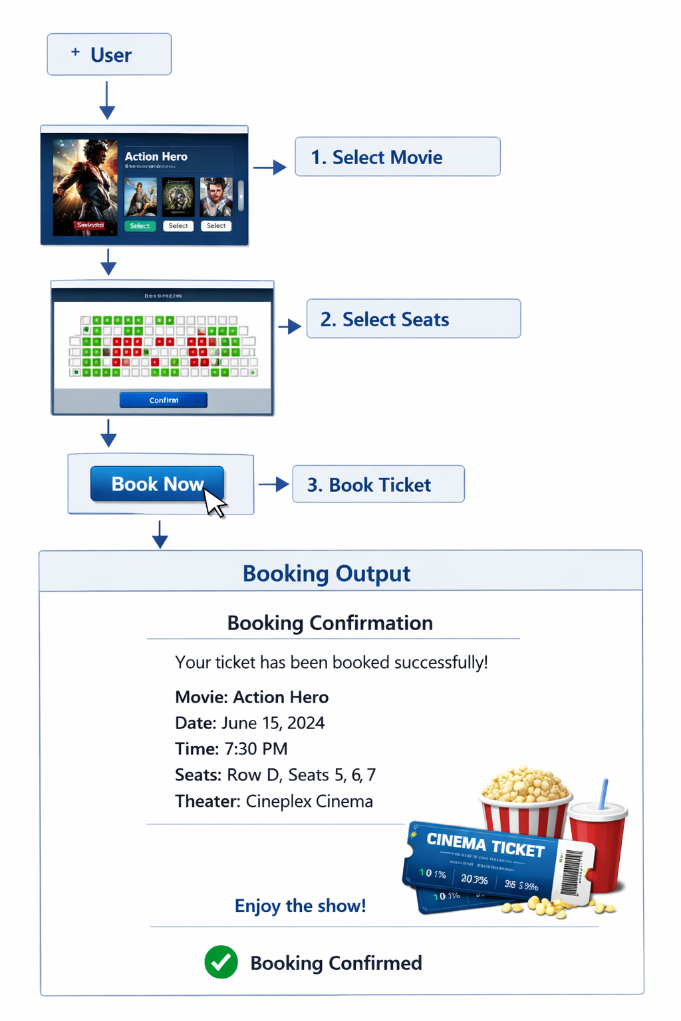

Explanation:
Level 1 DFD breaks the system into main processes.
It shows how the system works step-by-step like:
- Select Movie
- Select Seats
- Book Ticket
Data flows between these processes and user.

Level 2: Quiz Process (Example Sub-process)
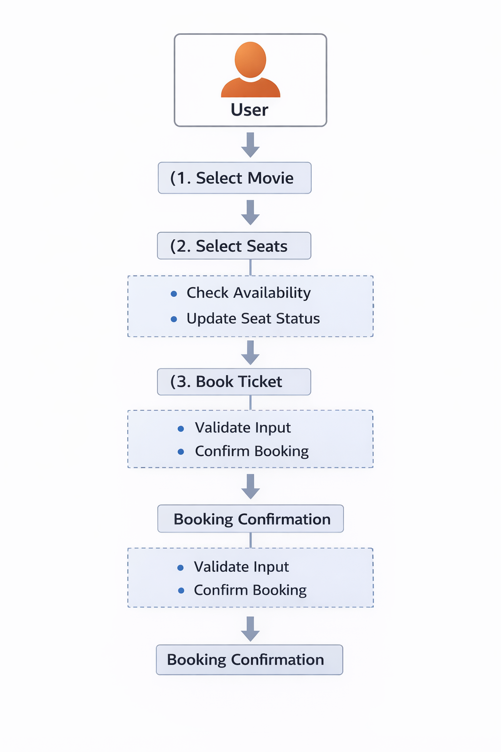

Explanation
Level 2 DFD gives detailed sub-processes of each step.
Example:
- Select Seats → Check availability → Update seat status
- Book Ticket → Validate → Confirm booking

6. Tools to Draw Your DFD
Free, easy online tools:
- https://app.diagrams.net (recommended)
- Lucidchart
- Creately
- StarUML
- Microsoft Visio
Steps (in draw.io):
- Go to https://app.diagrams.net.
- Create Blank Diagram
- Add shapes:
- Rectangle → User (External Entity)
- Circle → Process (Select Movie, Book Ticket)
  - Parallel lines → Data Store (Seat Data)
  - Arrow → Data Flow
- Connect all components with arrows
- Label each element clearly
- Arrange neatly
•
3.5 Entity Relationship Diagram (ERD)
Entities and Relationships
Entities:
- Movie (Movie_ID, Name, Image)
- Seat (Seat_ID, Status)
- Booking (Booking_ID, Movie_ID, Seat_ID, Total_Price)

Relationships:
- A Movie can have many Seats
- A User selects multiple Seats for booking
- A Booking is linked to one Movie and selected Seats
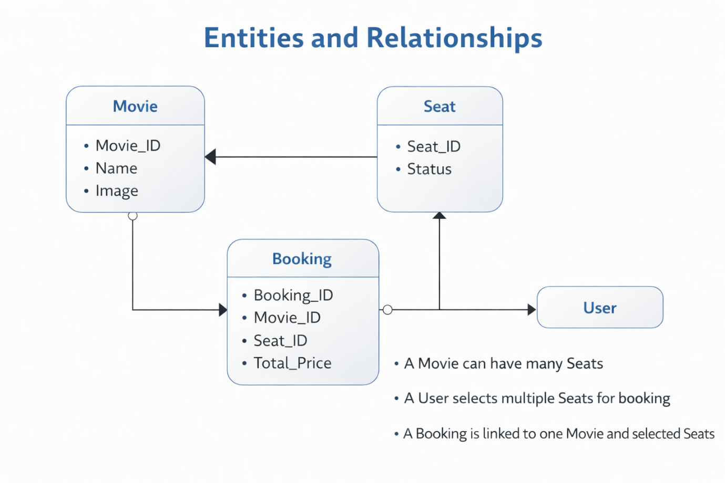

3.6 User Interface Design
The User Interface (UI) of the Movie Ticket Booking System is designed to be simple, attractive, and user-friendly. It allows users to easily interact with the system and perform booking operations.
Main Components:
- Movie Selection Dropdown: Allows users to choose a movie
- Movie Banner: Displays the selected movie image
- Seat Layout: Shows available, selected, and booked seats in grid format
- Legend: Indicates seat status (Available, Selected, Booked)
- Booking Button: Confirms ticket booking
- Message Display: Shows error or success messages

Design Features:
- Responsive layout
- Bright and attractive colors
- Easy navigation
- Interactive seat selection

Chapter 4: System Implementation
4.1 Introduction
System Implementation is the phase where the design is converted into a working application. In this project, the Movie Ticket Booking System is implemented using React.js to provide a dynamic and interactive user interface.
The system allows users to select a movie, view its image, choose available seats, and book tickets. React state management is used to handle seat selection, booking status, and price calculation efficiently. The implementation ensures smooth user interaction and real-time updates without reloading the page.

4.2 Development Tools and Technologies
Tool / Technology | Purpose
React.js | Frontend framework for building UI
JavaScript (ES6) | Handles logic and interactivity
HTML5 | Structure of the application
CSS3 | Styling and layout design
Visual Studio Code | Code editor for development
Browser (Chrome/Edge) | Running and testing the application

4.3 System Modules Description
Module | Description
Movie Module | Allows user to select a movie and view its poster
Seat Module | Displays seat layout and handles seat selection
Booking Module | Confirms ticket booking and updates seat status
Price Module | Calculates total price based on selected seats
Validation Module | Checks errors like no movie or no seat selected

Each module is interconnected through JavaScript functions, ensuring smooth navigation and state management within the website.

4.4 Implementation Details
The implementation follows a modular approach:
The Movie Ticket Booking System is implemented using a modular and component-based approach in React.js.
Frontend Design:
The user interface is designed using HTML and CSS to create a clean and responsive layout. It includes a movie selection dropdown, movie banner, seat layout, and booking button.

Dynamic Behavior:
React state (useState) is used to manage:
- Selected movie
- Seat status (available, selected, booked)
- Total ticket price
The UI updates dynamically based on user actions without page reload.

Event Handling:
User actions such as selecting a movie, clicking seats, and booking tickets are handled using event functions like:
- onChange for movie selection
- onClick for seat selection and booking

Booking Logic:
- Seats toggle between available and selected
- Booked seats cannot be selected again
- Total price is calculated based on selected seats
- Booking updates selected seats to booked

4.5 Algorithm / Logic of Core Function

Algorithm for Seat Selection
- Start
- User clicks on a seat
- Check if seat is booked
  - If yes → Do nothing
  - If no → Continue
- Toggle seat status:
  - Available → Selected
  - Selected → Available
- Count selected seats
- Calculate total price = seats × ticket price
- Display updated seats and total
- Stop\
Algorithm for Booking Tickets
- Start
- Check if movie is selected
  - If no → Show error
- Count selected seats
- Check if seats selected
  - If no → Show error
- Convert selected seats → booked
- Update seat status
- Show success message
- Reset total price
- Stop

4.6 Security and Validation
Basic validation is implemented to ensure correct booking.
The system checks whether a movie is selected and at least one seat is chosen before booking. Invalid actions are prevented, and appropriate error messages are displayed to the user.

4.7 Integration
All modules such as movie selection, seat selection, and booking are integrated using React state. Data flows smoothly between components, ensuring real-time updates and seamless user interaction.

4.8 Output Screens (Snapshots)
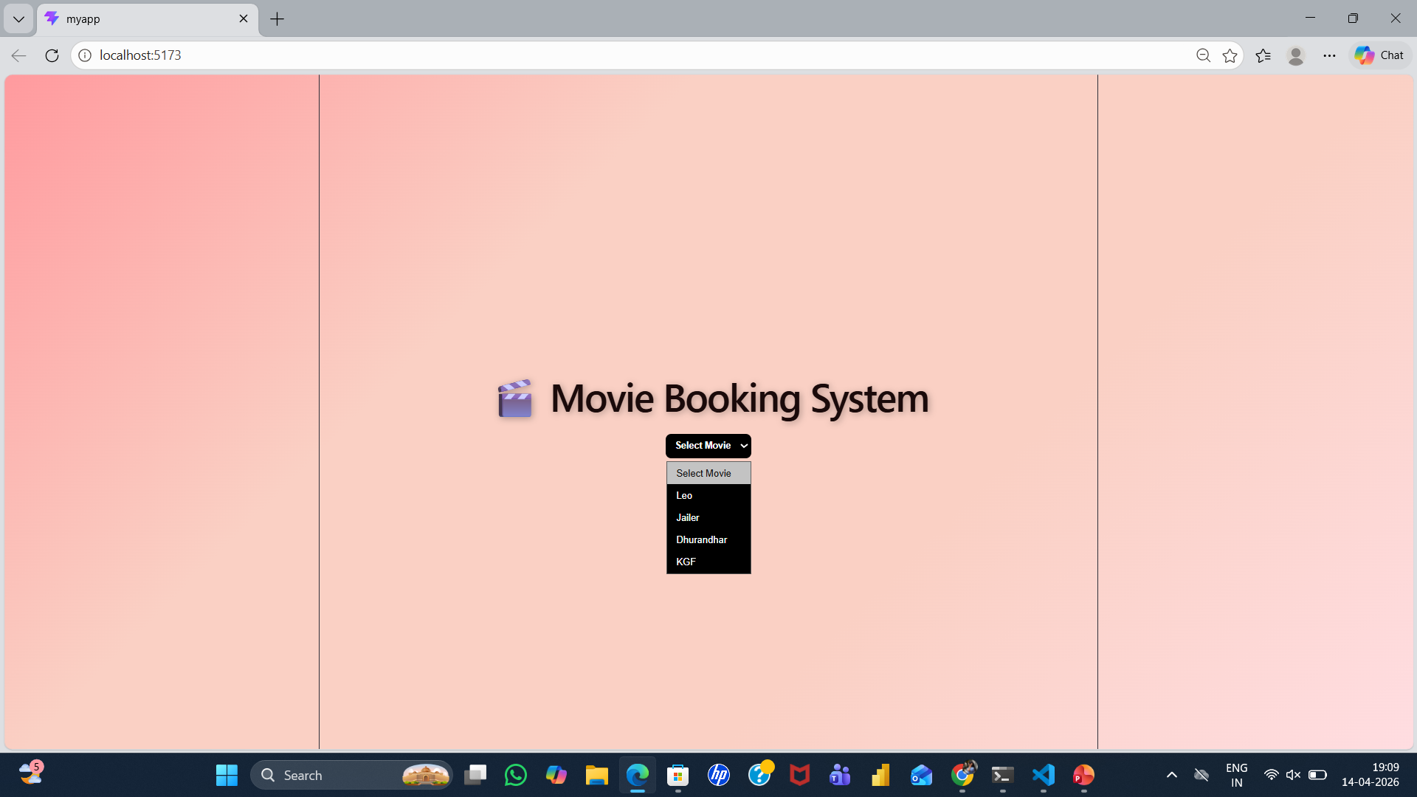

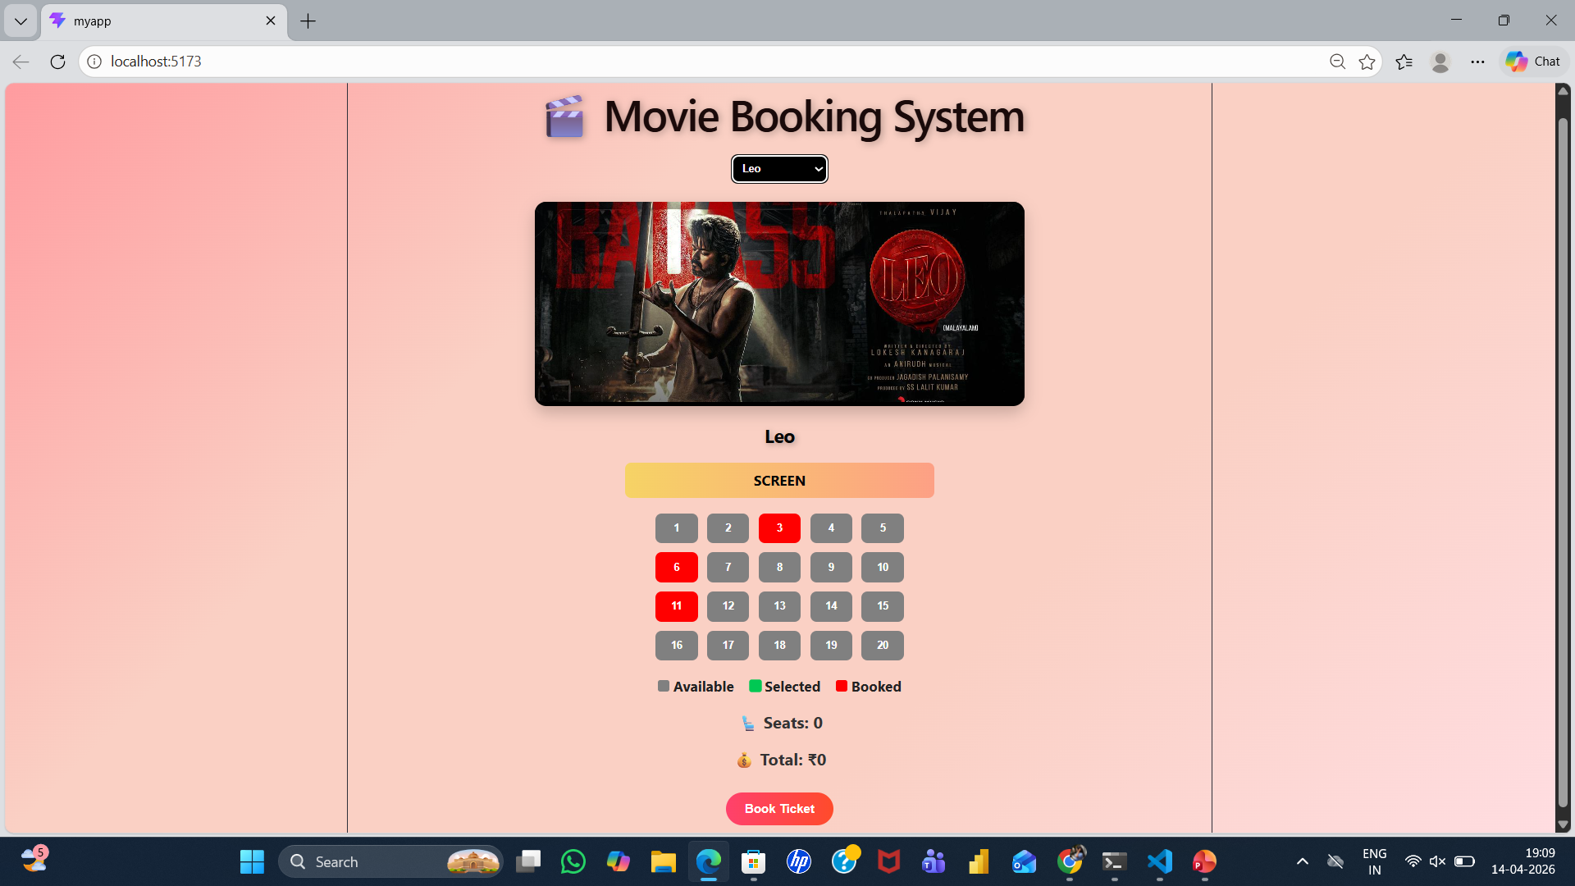
Chapter 5: System Testing
5.1 Introduction
System testing is an important phase that ensures the Movie Ticket Booking System works correctly and meets all functional and non-functional requirements. It verifies whether the system performs as expected when users select movies, choose seats, and book tickets.
Testing was conducted to check the functionality of modules such as movie selection, seat booking, price calculation, and booking confirmation.

5.2 Objectives of Testing
- To ensure all modules (Movie, Seat, Booking) function correctly
- To identify and fix logical or runtime errors
- To verify correct output for user inputs
- To ensure smooth performance across browsers and devices

5.3 Types of Testing Performed
a) Unit Testing
Each function such as seat selection, price calculation, and booking logic was tested individually.

b) Integration Testing
All modules were combined and tested together to ensure smooth flow:
Movie Selection → Seat Selection → Booking

c) System Testing
The complete application was tested to ensure all features work properly, including seat updates and booking confirmation.

d) User Acceptance Testing (UAT)
The system was tested by users to check usability, interface design, and overall experience.

e) Cross-Browser Testing
The system was tested on browsers like Chrome and Edge to ensure compatibility and responsiveness.

5.4 Test Plan
Test ID | Module | Test Description | Type | Expected Output | Status
T01 | Movie | Select movie | Functional | Movie image displayed | Pass
T02 | Seat | Select available seats | Functional | Seat turns green | Pass
T03 | Seat | Click booked seat | Logic | No change | Pass
T04 | Booking | Book without selecting seats | Validation | Error message shown | Pass
T05 | Booking | Book with selected seats | Functional | Seats turn red | Pass
T06 | Price | Calculate total | Logic | Correct total displayed | Pass
T07 | UI | Responsive layout | UI | Works on mobile/desktop | Pass

5.5 Test Data and Execution
Sample movie data and seat values were used for testing.
User actions such as selecting movies and seats were performed, and outputs were verified by comparing expected and actual results.
5.6 Error Handling
- Error message shown if no movie is selected
- Error message shown if no seats are selected
- Booked seats cannot be selected again
- Proper messages guide users for correct actions
5.7 Performance and Usability Testing
- Performance: Fast response with instant UI updates
- Usability: Easy navigation and interactive design
- Accessibility: Clear layout and readable interface
5.8 Results and Observations
All modules worked correctly. The system was responsive, user-friendly, and efficient. No major errors were found during testing.

Chapter 6: Results and Discussion
6.1 Introduction
This chapter presents the results obtained after implementing and testing the Movie Ticket Booking System. It explains how each module performed and how effectively the system achieved its objectives.
6.2 System Outputs
During execution, the system produced the following outputs:
- Movie Selection: Displays list of movies in dropdown
- Movie Banner: Shows selected movie image
- Seat Selection: Displays seat layout with available, selected, and booked seats
- Booking System: Allows user to book selected seats
- Confirmation Message: Shows success message after booking
The system was tested and verified to work properly on both desktop and mobile devices.

6.3 Performance Analysis
- Responsiveness: Fast UI updates using React state
- Accuracy: Seat selection and price calculation are correct
- Stability: No errors during repeated booking operations
- Compatibility: Works on Chrome and Edge browsers
6.4 User Feedback
Users tested the system and provided feedback:
- Easy to use interface
- Clear seat selection system
- Attractive UI design
- Suggested adding payment and login features

Chapter 7: Conclusion and Future Enhancement
7.1 Conclusion
The Movie Ticket Booking System successfully demonstrates how React can be used to build an interactive and user-friendly web application. The system allows users to select movies, choose seats, and book tickets efficiently.
All modules such as movie selection, seat booking, and price calculation work correctly. The system meets its objectives of providing a simple, responsive, and dynamic booking platform.
This project shows how modern web technologies can be applied to real-world applications like online ticket booking systems.

7.2 Limitations
- No database integration (data stored in state only)
- No payment system
- No user login feature
- Limited movie data

7.3 Future Enhancement
The system can be improved with the following features:
- Database Integration: Store bookings using Firebase or MySQL
- User Login: Add authentication for users
- Online Payment: Integrate payment gateway
- Admin Panel: Manage movies and bookings
- Multiple Shows: Add timings and screens
- QR Code Ticket: Generate digital tickets
- Cloud Deployment: Host online for real-time use

8: References
8.1 Books & Journals
- Web Technologies: HTML, CSS, JavaScript, PHP, Java, JSP, XML, and AJAX — Uttam K. Roy, Oxford University Press.
- Learning Web Design — Jennifer Niederst Robbins, O’Reilly Media.
- JavaScript and React Development — Various Online Resources

8.2 Online Resources
- MDN Web Docs — https://developer.mozilla.org
- W3Schools — https://www.w3schools.com
- Bootstrap Official Documentation — https://getbootstrap.com
- JavaScript.info Tutorials — https://javascript.info
- FreeCodeCamp Tutorials — https://www.freecodecamp.org
- GeeksforGeeks Web Development Articles — https://www.geeksforgeeks.org

8.3 Tools & Frameworks Used
- Editor: Visual Studio Code
- Languages: JavaScript (ES6)
- Framework: React Js
- Database (Future Scope): Firebase / MySQL
- Browser: Google Chrome / Microsoft Edge

Appendices
Appendix A – Source Code Include your main source files:
- App.jsx — Main React component (movie selection, seat booking)
- App.css — Styling and layout design
- main.jsx — React entry point
(Include only important code snippets such as seat selection logic and booking function.)

Appendix B – Screenshots of Web Pages
Attach labeled screenshots:
- Figure 1.1: Homepage (Movie selection dropdown)
- Figure 1.2: Movie Banner Display
- Figure 1.3: Seat Selection Interface
- Figure 1.4: Booking Confirmation Message
- Figure 1.5: Responsive Mobile View
(Ensure each image has a caption and is referenced in your report.)
Appendix C – User Manual / Installation Guide
Steps to Run the Project:
Steps to Run the Project:
- Install Node.js (if not installed)
- Open project folder in VS Code
- Run the command:
npm install
- Start the project:
npm run dev
- Open the local server link in browser
- Select movie, choose seats, and book tickets

System Requirements:
- OS: Windows / macOS / Linux
- Browser: Chrome / Edge
- RAM: Minimum 4 GB
- Storage: 200 MB free

